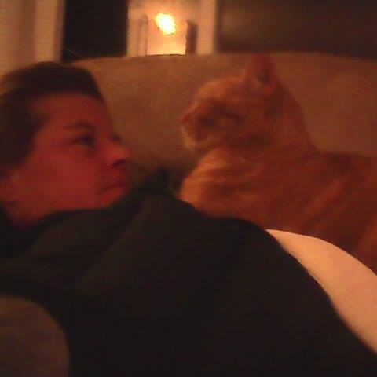

Really nice to find you two! Hard to believe, at least for me, that it has been 30 years since I did the Alivening Weekend and the week long...You two do such wonderful work. Thank you for all that you do in this world and thank you for what you did for me. Not a day has gone by where I don't practice what you two brought out in me…. ‎Stacey Drasky‎

